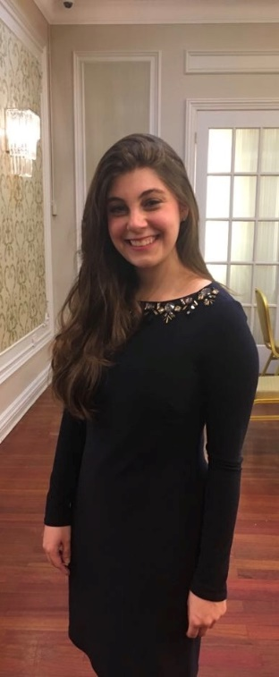
Tammy Bodner
Cedarhurst, New York
Birth Date: January 11, 1994
Contact Phone#: 516-426-2992

Schools:
Shulamith (Long Island) Elementary
SKA High School
Stern College – Graduated Spring 2015
Developmental Psychology Major
Queens College Graduate School – Graduated May 2018
Masters in School Psychology
Employment:
Department of Education School Psychologist in Brooklyn
Owner of children’s clothing company

Parents:
Father - Yakov Bodner -Owner of Telecom Business
- Baal Koreh and served as president of shul for 7 years
Mother - Estie (Schulhof) Bodner -North Shore Hebrew Academy HS Special Ed Teacher
Grandparents:
Maternal- Chazzan Moshe A”H and Ruchama Schulhof
Paternal- Naftali A”H and Alice Bodner
Siblings:
Daniel- 30 years old (Marketing Analyst) married to Sefi (nee Shuman)
Shani - 22 years old (Office Administrator at tile company) married to Eli Steiner
Michal -20 years old, Queens College
Shul: Kehillas Bais Yehudah Tzvi (Red Shul)
Rabbi & Rebbetzin Yaakov Feitman – (516) 850-4777
References:
Mr. & Mrs. Jay Shuman (mechutanim) - 908-612-5787 or 908-906-7344
Mrs. Naomi Cohen (family friend) - 516-569-5759
Mrs. Ruchama Frisch (family friend) - 646-872-2829
Sefi (Shuman) Bodner (Sister in law and friend) - 908-419-7933
Chanie Shalmoni (Tammy’s friend) - 718-614-7984
Tanya Schulman (Tammy’s friend) – 845-826-0378

About Me:

I consider myself a down to earth person, who loves to travel. People would describe me as friendly, loyal and someone you can count on. Though my schooling may seem more modern, I have always been more to the “right” frum wise. I come from a heimish family that values living in a modern world yet keeps to a frum home. I follow hilchos tznius and as the women in my family do, I intend to cover my hair when married.

What I am looking for:

I would like a professional who grew up going to yeshiva type schools. I’d also like for him to be makpid on davening three times a day and have a strong connection to Yiddishkeit while still being part of the secular world. Most important to me is someone who is a “mentch”. I am looking for someone who is sensitive to other’s feelings, sincere in his words and actions, humble and is well respected. I am looking for someone to build a life with, a family and someone who will share the ups and downs of life.

